**Programs on Methods and Constructors**

1. Write a program to calculate the Area and Perimeter of a rectangle. Use different methods (Area and Perimeter) for the demonstration.

**Logic:**

Step 1: Start

Step 2: class area{ public class area{

Step 3: Now just declare a class named “area” and inside it declare two integers to receive the value of

length and breadth of rectangle.

Step 4 : We have to then declare perimeter class and again receive length and the width of the rectangle

apply the formula and return the value.

Step 5: So, now we have to then declare a main class where the length and width of the rectangle is transferred to

the above classes.

Step 6: At the end we just have to receive the value from the above classes print the results.

Step 7: Stop

**Code:**

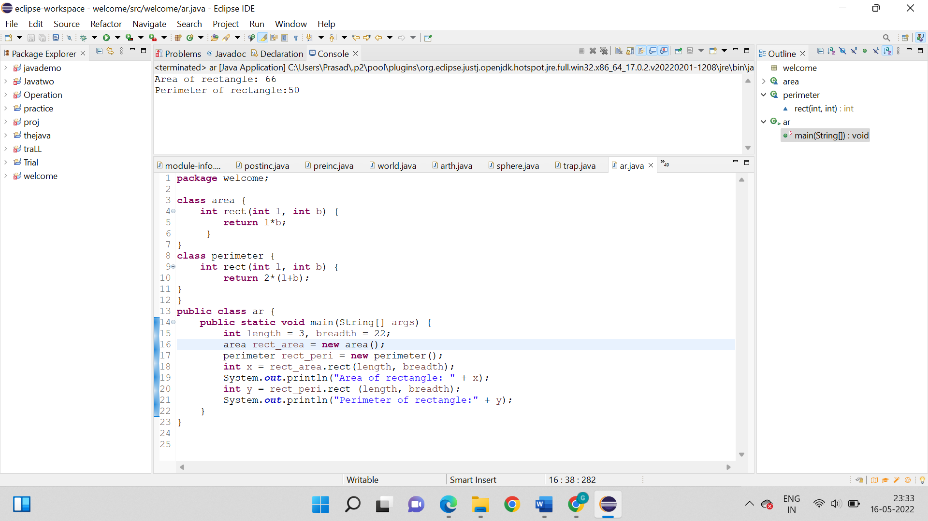

**Output:**

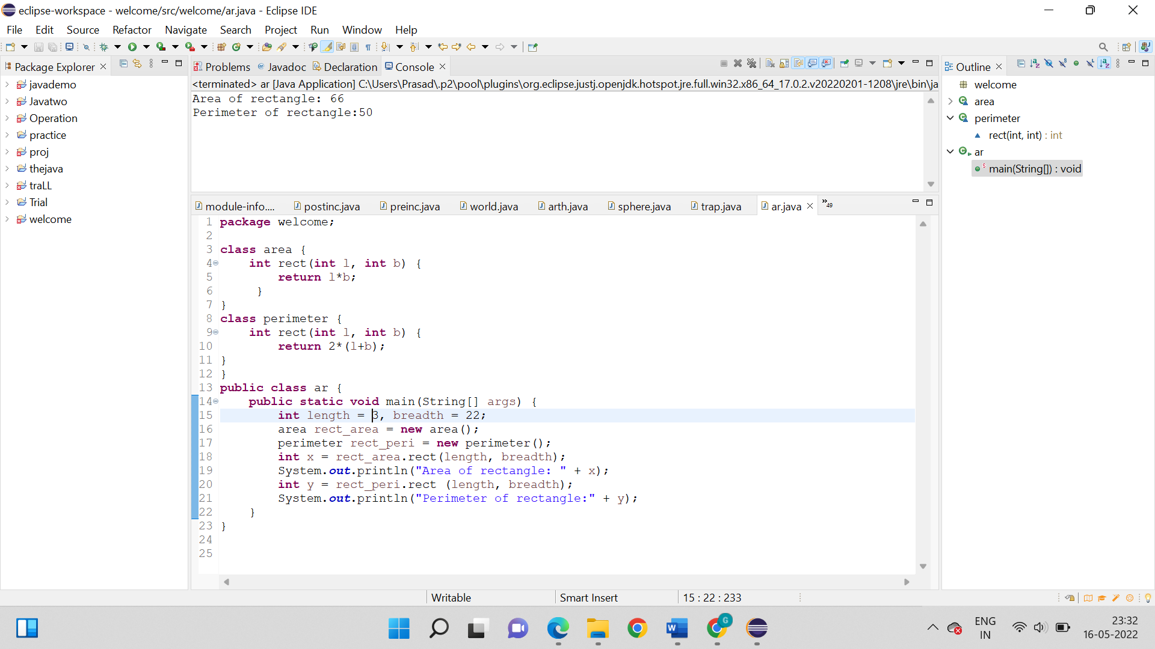

1. Write a program to determine where the number is a positive number or negative number. Use if else statement and different methods (Positive and Negative) for the demonstration.

**Logic:**

Step 1: Start

Step 2: Package welcome ;

Step 3: Class positive_number{ public class ar {

Step 4: We have to create two sub-classes positive and negative.

Step 4: After that we create methods in it.

Step 5: Now, these methods will receive a integer from the main class and using if operator will check if the number is less than zero or greater than zero.

Step 6: So, now we have to see n the sub-class positive if the number is greater than zero than it will return 1, else 0.

Step 7: After step 6, the sub-class will return the value to the main class.

Step 8: Now the negative sub class will compare the value with 0, and return the value.

Step 9: As we know that in the main class, call the methods in the sub-classes.

Step 10: Now, we just have to pass the numbers to it through if…else loop and printing the results

Step 11: Stop

**For negative number:**

**Code**

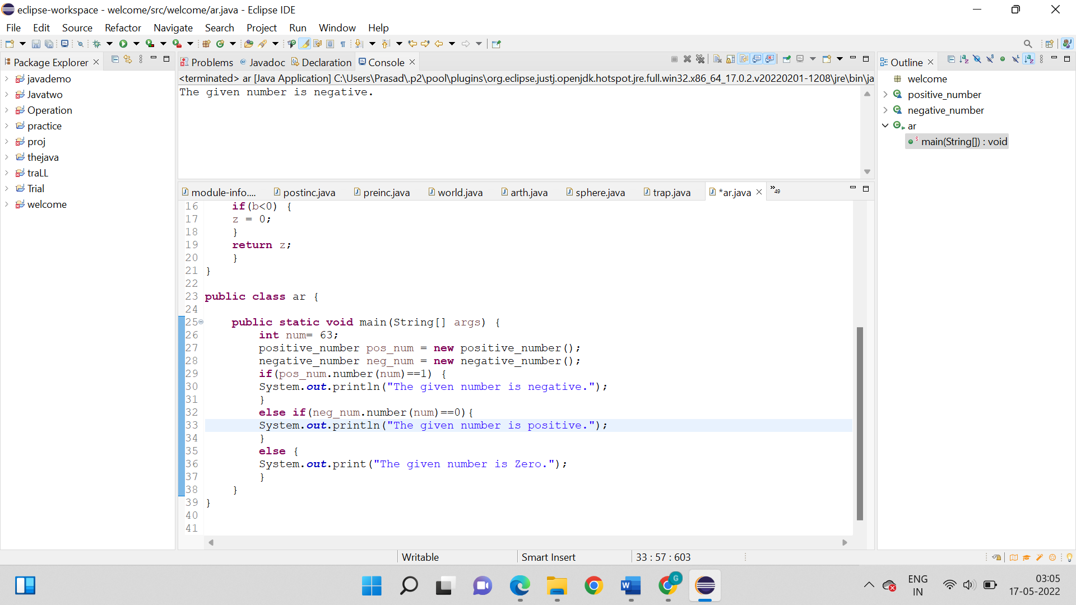

**Output:**

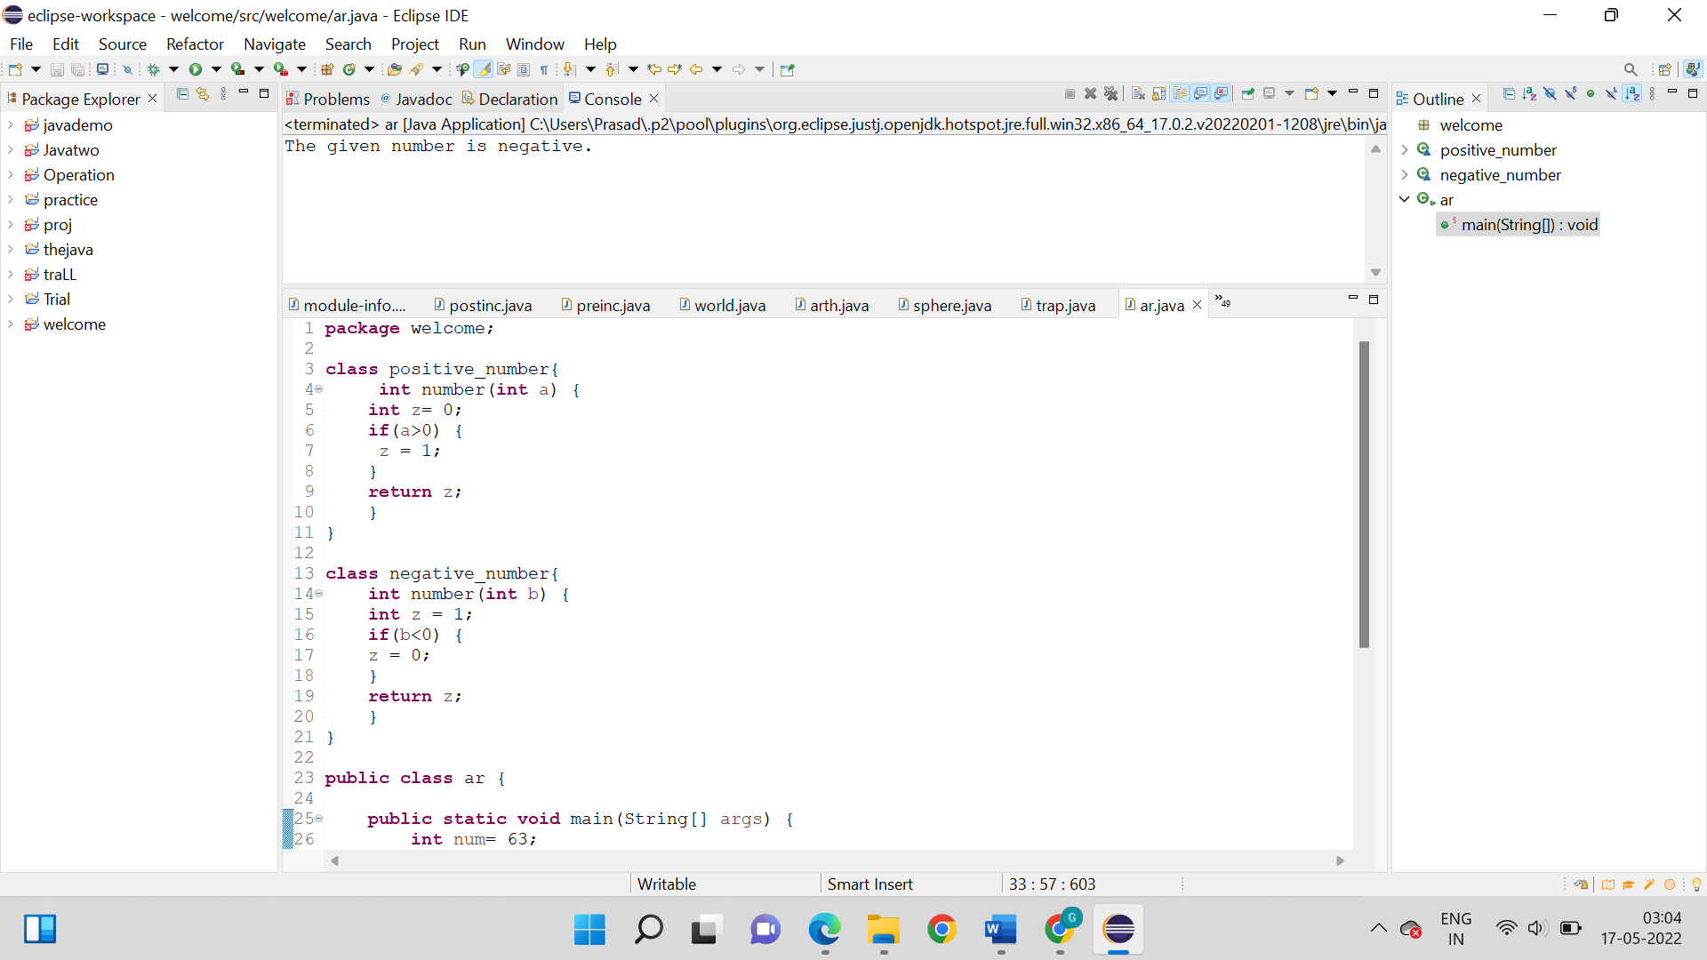

**For positive number:**

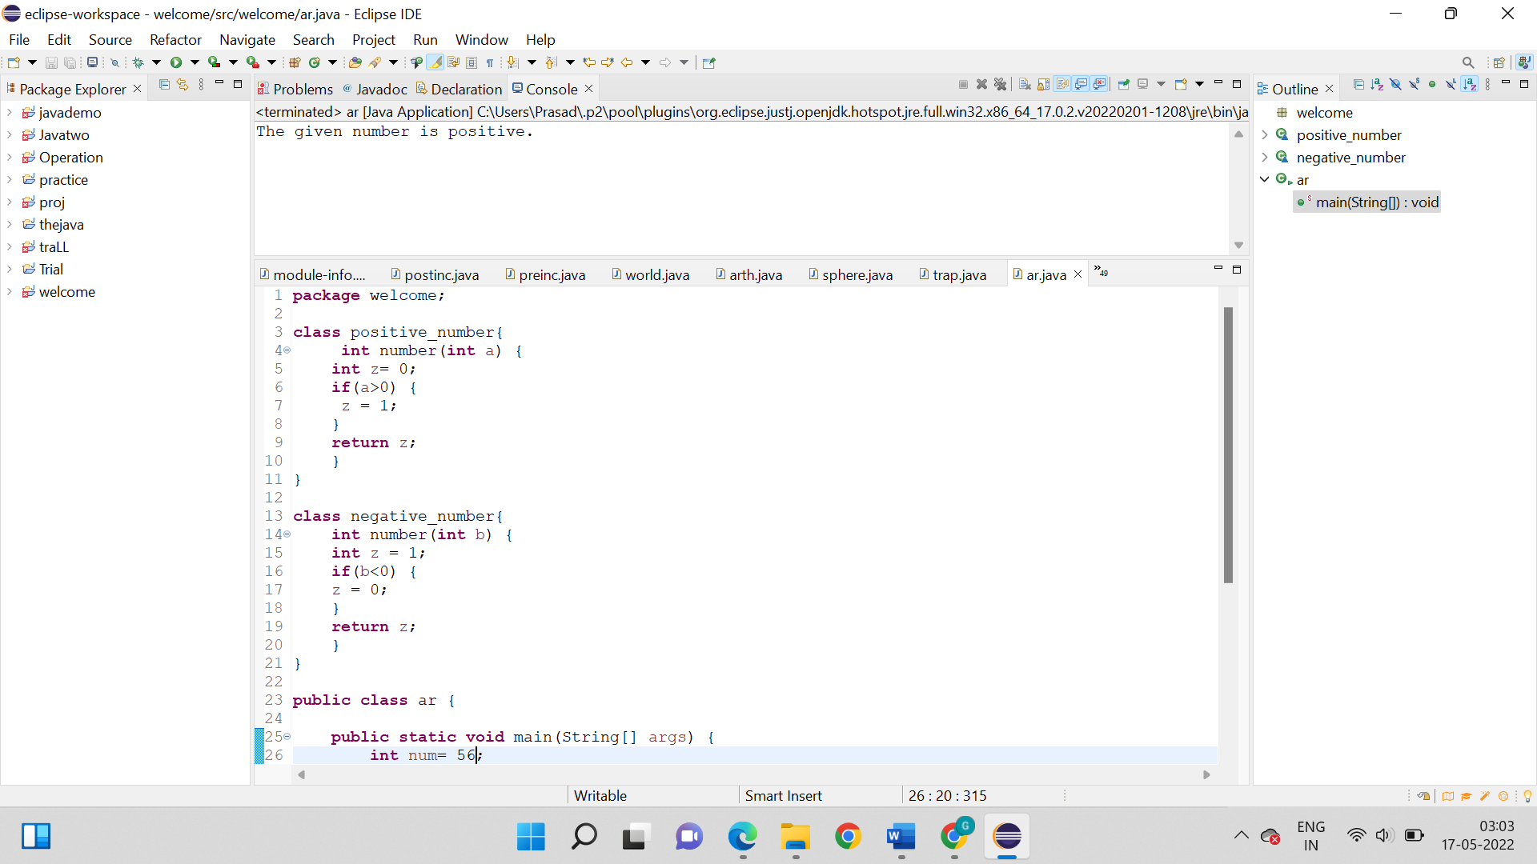

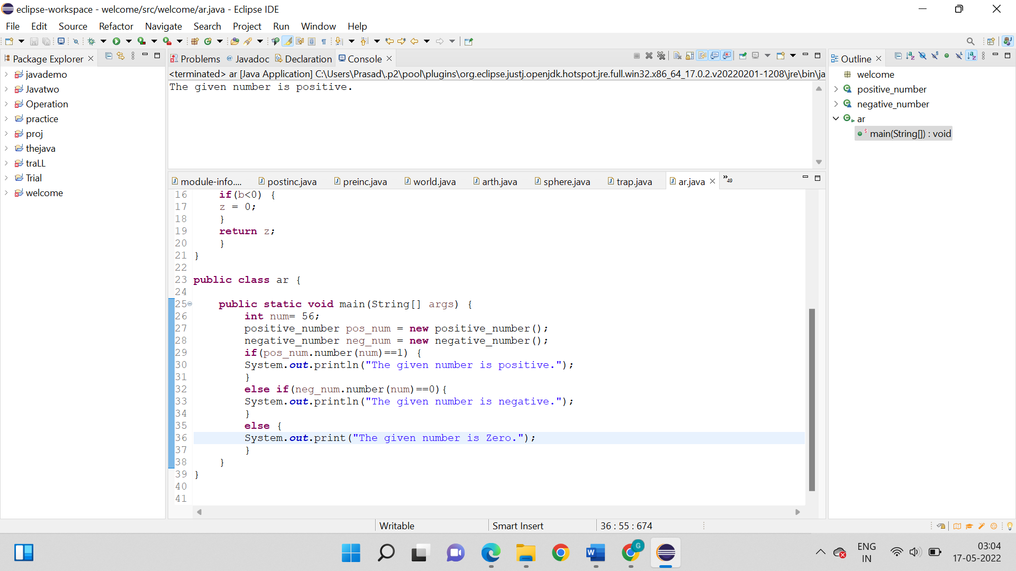

**Output:**



1. Write a program to demonstrate the use of constructor for creating students’ profile consist of First Name, Last Name, Department, Marks. Use this keyword for the demonstration.

**Logic:**

Step 1: Start

Step 2: package welcome { class Student { So we need to create a class named student and create three String variables namely firstname, lastname and department. Also create an integer variable for marks.

Step 3: Now we need to inside the same class create a Student constructor, that will receive the all the above variables.

Step 4: So, now as we know inside the constructor also make use of ‘this’ operator.

Step 5: Then in a void class print the result in the required format.

Step 6: So, at last finally in the main class create two methods that will transfer your data to the Student class and then call for the void class which will print the result.

Step 7: Stop

**Code:**

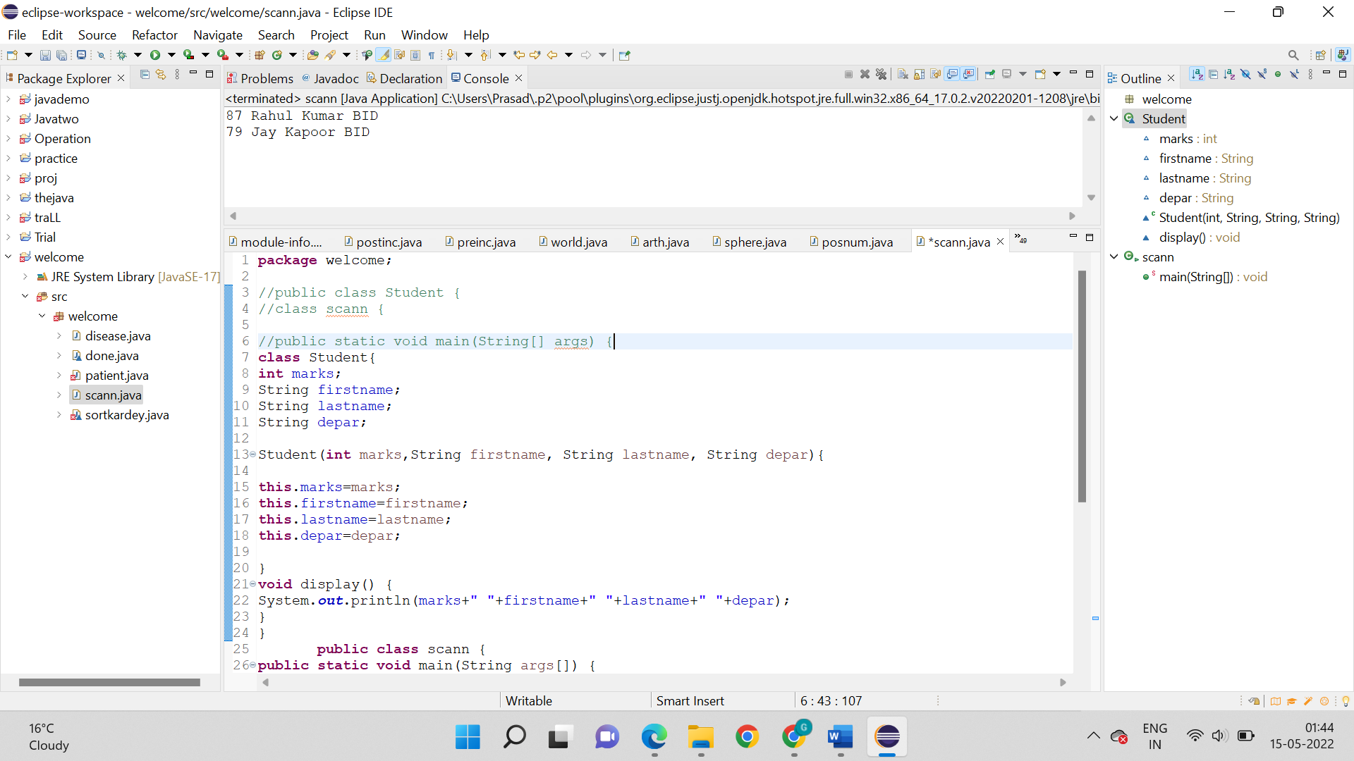

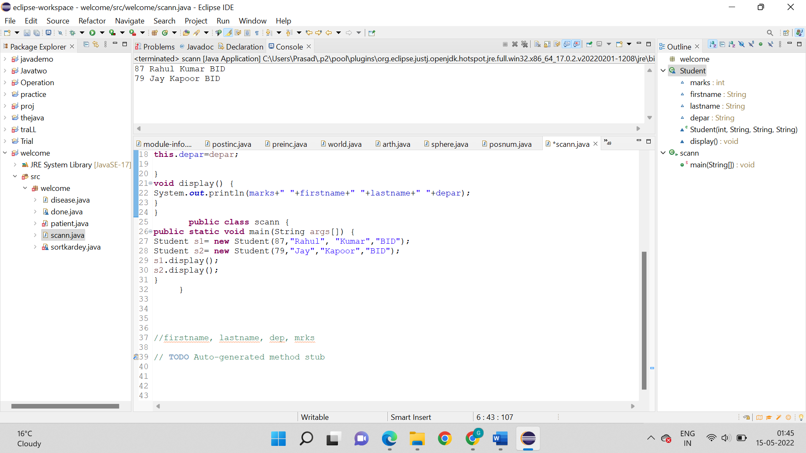

**Output:**

